**Unit 1B World War 1**  Grade on Notes Name and Period

**Topics Covered:**

* Examine how World War I affected the military and the home front of the United States.
* Identify major causes of World War I and the United States’ involvement and influence in the war; e.g., Wilson’s Fourteen Points, the Versailles Treaty.
* Determine the reasons the United States Senate refused to join the League of Nations.
* Examine the impact World War I had on the United States; e.g., government policy, industrial might, civil liberties.

**Vocabulary:**

Alliance System____________________________________________________________________________

__________________________________________________________________________________________

Gavrilo Princip____________________________________________________________________________

__________________________________________________________________________________________

No-man’s-land_____________________________________________________________________________

__________________________________________________________________________________________

Zimmerman Note__________________________________________________________________________

__________________________________________________________________________________________

Selective Service Act_______________________________________________________________________

__________________________________________________________________________________________

John J. Pershing____________________________________________________________________________

__________________________________________________________________________________________

Committee on Public Information____________________________________________________________

__________________________________________________________________________________________

Espionage Act_____________________________________________________________________________

__________________________________________________________________________________________

Reparations_______________________________________________________________________________

__________________________________________________________________________________________

Bolsheviks________________________________________________________________________________

__________________________________________________________________________________________

Treaty of Brest-Livotsk______________________________________________________________________

__________________________________________________________________________________________

Fourteen Points____________________________________________________________________________

__________________________________________________________________________________________

League of Nations__________________________________________________________________________

__________________________________________________________________________________________

Flu Epidemic of 1918_______________________________________________________________________

__________________________________________________________________________________________

Treaty of Versailles________________________________________________________________________

__________________________________________________________________________________________

**Activities**:

Causes of World War I

Newspaper of WW1

**In-Class Films:**

Shell Shock

Excerpt from “The Lost Battalion”

**Class Webpage:**

www.msgurr.weebly.com

**Readings:**

Historian Articles on Causes of World War I

Excerpt from the Treaty of Versailles

**Textbook Chapter 12.**

**Assignments**:

Vocabulary and Homework Questions

Causes of World War I Take Home Test

WW1 Newspaper

**Homework Questions:**

1. Why did America move from being a neutral, isolationist country to fighting in World War I?

2. What is Trench Warfare? How was war fought in the trenches? What weapons were used, how did they advance the line forward, and how effective of a method of war was it?

3. What is propaganda? How was it used during the war? List and explain two examples.

**Timeline: On the timeline below write in 10 major events of World War 1.**



**Main Points/Ideas**

**Notes**

**World War I**

**Notes**



**Main Points/Ideas**



**Notes**

**World War I**

**Notes**



**Main Points/Ideas**

**Notes**

**World War I**

**Notes**

**Map Activity: On the map of Europe draw in/label:**

1. 3 major battles of World War 1

2. Where the Lusitania was sunk.

3. Where the highest concentration of U-boats was.

4. The general line of the Western Front from 1914-1918.

5. Label countries of the Allied Powers in blue and Central Powers in red.

**List:** Allied Powers and Colonies Central Powers

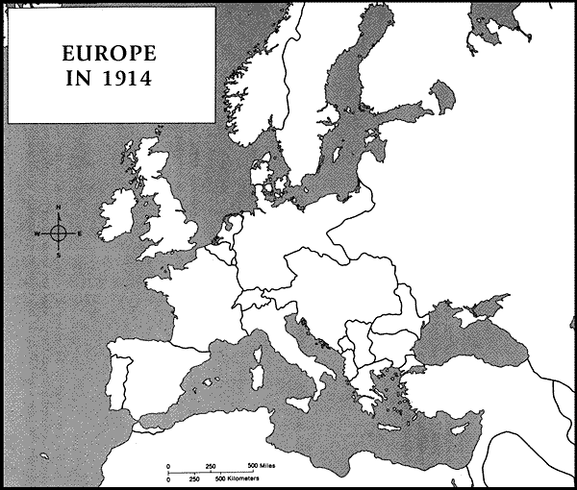

|  |  |  |
| --- | --- | --- |
| What did the Treaty of Versailles mean for Germany and for Europe? | | |
|  | **Germany** | **Europe** |
| War Guilt Clause |  |  |
| Reparations |  |  |
| Military |  |  |
| Land |  |  |
| Peace Keeping |  |  |

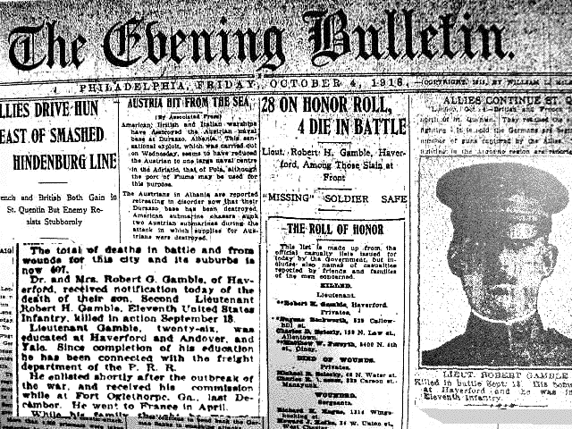World War One Newspaper

You are a journalist for a United States newspaper during World War 1. Your job is to write an edition of this newspaper. Your paper needs to include articles about the progress of the war (battle updates, etc) as well as what life is like at home. You need to show an understanding of the course of World War I and the character of the war at home and abroad.

* Requirements: minimum one full page and at least two articles and one advertisement.
  + One article must be about a battle or incident in the war.
  + The second article must be about life at home in America.
  + The advertisement must be US government propaganda (you can make your own or find an ad FROM THE U.S. DURING WORLD WAR ONE online that you can use.)
* The newspaper must be typed.
* If you choose to include photographs you may have up to 3 per page, as appropriate, but each photo may be no more than 1” by 1”.
* **Extra credit** will be given for each additional page of the newspaper, up to 15 extra credit points.

**Some excellent resources to use:**

* <http://www.firstworldwar.com/>
* <http://www.worldwar1.com/>
* <http://www.pbs.org/greatwar/>
* <http://www.theworldwar.org/s/110/index.aspx>
* <http://www.bbc.co.uk/history/worldwars/wwone/>

**You will be graded on:**

* Historical accuracy
* Creativity
* Overall neatness and organization
* Whether you meet the requirements listed above