April 23, 1942
Dear Miss Breed,
I hope you will forgive me for not saying goodbye, and for not writing you sooner.
How is San Diego?
I find "camping life" very nice. We are all given a button which has a one, a two, or a three on it so that we may have our meals at certain hours. I having a one, eat breakfast from 6:30 to 7:00, lunch at 11:30 to 12:00, and dinner at 4:30 to 5:00. The food is simple, but delicious and wholesome. I did not have to cook or wash the dishes as there are many cooks and waiters in the cafeteria. I love cooking, but thank heavens I do not have to do the dishes! Since I have a two and a half months brother, I wash daily, and sweep out my barrack. About three times a week I iron the family’s clothes. There is really not much I may do in the afternoon, but get my exercise playing dodge ball, catch or softball. Once in a while, I type manuscripts for my friends, or write letters. I retire every night between 9:30 to 10:00 p.m. All lights should be out by 10:00 in each barrack.
I went over Louise Ogawa’s barrack and saw the two very interesting books you sent her. I certainly love books and miss going to the library every week; so I decided to write you a letter.
Florence is going to school daily from 2:00 to 4:00 and enjoys it very much. She tells me she misses going to the library and asked if I would write to you. She acquired her highest grades in reading, and she truly enjoys it.
I especially enjoy Dodd, Mead Career Books and would very much like to have any of the following books:
1. Shirley Clayton: Secretary by Blance L. Gibbs and Georgiana Adams
2. Judy Grant: Editor by Dixie Wilson
3. Marian-Martha by Lucile F. Fargo
4. Press Box by Robert F. Kelley.
If you happen to have any discarded books, Florence and I would certainly appreciate them.
Please keep up the good work in teaching children to read books for that is the pathway to happiness!
I am enclosing dolls that Florence made in school and some stamps.
Sincerely yours,
Florence and Margaret Ishino

September 14, 1942
Dear Miss Breed,
We are all getting used to the weather and dust and beginning to think that it isn't such a bad place after all. Partitions have been put up in the lavatory and the wash room here is much nicer and much closer [than in Santa Anita].
We have each been given a cot bed and a blanket. Now that we have caught up on our sleep, the cots feel rather uncomfortable. We will be issued either hay or steel army cots and matresses, but as yet no one seems to know when! Something should be done, though, because we need something as a mattress because it is colder at night.
It seems as though my life is going through a thorough transformation! Here I go to Sewing School, Sunday School, Church, Singsperation, and Girls' Club Meetings. No more of those swell Saturday night dances! Gee, how I miss them!... The young girls from Reedley, Visalia, and Fresno and thereabouts no longer go to dances cause they are afraid of the "Santa Anita yogores" (a colloquialism meaning "not the best of boys"). Due to this, the young fellows act twice as rowdy and really make us disgusted!
We, [Santa Anita] girls no longer go out to dances either! Most of us stay at home and are truly good girls. Sometimes we go to each others house and look up into the dark blue star-filled sky. I regret that I did not take astronomy in school — the sky is truly beautiful at night!
I know I'm asking a great deal of you — but I wonder if you would be so kind as to send me a dictionary. If you have one that you don't need, would you please send it to us. If you don't have an extra one I will send you the money for one in my next letter.
Gee, Christmas must fall on Friday! It certainly would be elegant if you could come to Arizona. Visitors here are allowed to enter the barracks and visit people. It doesn't feel like a prison here. Gee, but this is such a desolate place I wonder if your tires will hold out -also your gas will be rationed won't it?
Please give your mother our best regards. My mother sends you her love.
Sincerely,
Fusa

322-14-d
Poston, Arizona
November 16, 1942
Dear Miss Breed,
Guess who? Yup it's ole unreliable again, none other than yours truly, Tetsuzo. Gosh the wind's been blowing all night and all morning. Kinda threatening to blow the roofs down. Dust is all over the place. Gives everything a coating of fine dust.
The food has been all right except for quantity...The medical situation here is pitiful. For that matter in all three camps. The main and the only hospital is at Camp I 15 miles away. Here in Camp III there is one young doctor with not too much experience and one student doctor working in an emergency clinic. They are supposed to take care of approximately 5000 people!!!! and they (the Big shots) wonder why we squawk about inadequate medical attention.
No I haven't hiked to the river yet. I'd better do it soon cause there is going to be a fence around this camp!!!!!! 5 strands of barbed wire!!!!!!!!!! They say it's to keep the people out. . . . It's also to keep out cattle. Where in the cattle countries do they use 5 strands of barbed wire??
If they don't watch out there's going to be trouble. What do they think we are, fools?? At Santa Anita at the time of the riot the armored cars parked outside of the main gates, pointed the heavy machine guns inside and then the army had the gall to tell us that the purpose of that was to keep the white folks from coming in to mob the Japs. Same thing with the guards on the watch towers. They had their machineguns pointed at us to protect us from the outsiders, hah, hah, hah, [I'm] laughing yet.
I am sending you a few things in appreciation for what you have done for me as well as for my sister and all the rest.... Your name plate I made from mesquite as are also the lapel pins. However the dark pin is made from a pine knot from Santa Anita. The rest are all Poston Products.
I've got to close now so that I can make the outgoing mail today.
Very truly yours,
Tetsuzo
P.S. Have a nice Thanksgiving dinner. TH
P.S. Do you think you could send me some Welch's peanut brittle? TH

"Japan is ready, in case of war, to hit us hard -- from the inside. Japanese on the West Coast are well prepared for the event. They have assembled detailed data on our vital Pacific defenses. They possess the bases, the equipment and the disciplined personnel with which to strike either through sabotage or open acts of war... In the Japanese fishing fleet, obligingly allowed to share harbor space here with the United States Navy, there are 250 vessels. Many of them, perhaps 90 percent, are manned by reservist officers and sailors of the Japanese Navy. Inshore they fly the Stars and Stripes, as required by law -- at sea they frequently run up the flag of the Rising Sun, as the government has photographs to prove..."

Letter by Stanley High, "Japanese Saboteurs in Our Midst," Readers Digest, Jan. 1942

"The Japanese race is an enemy race and while many second and third generation Japanese born on United States soil, possessed of United States citizenship, have become Americanized, the racial strains are undiluted… Along the vital Pacific Coast over 112,000 potential enemies, of Japanese extraction, are at large today. There are indications that these are organized and ready for concerted action at a favorable opportunity. The very fact that no sabotage has taken place to date is a disturbing and confirming indication that such action will be taken."

General DeWitt to Secretary of War Stimson, February 14, 1942

"We Americans, in spite of our democratic ideals, too often allow unreasonable prejudice to deprive people of races other than white, of the full privileges that should be theirs as native-born citizens of the United States... The American citizen of Japanese ancestry is likely to be discriminated against because of superficial physical characteristics that have no influence whatsoever on the quality of his mind, on the strength of his character, or the depth of his loyalty to the United States. Every good citizen should recognize this danger and do all in his power to counteract it, whatever may happen on the other side of the Pacific."

Robert Gordon Sproul, President of the University of California, Dec. 23, 1941

“Virtually all Japanese are short. Japanese are likely to be stockier and broader-hipped than short Chinese. Japanese are seldom fat; they often dry up and grow lean as they age. Although both have the typical epicanthic fold of the upper eyelid, Japanese eyes are usually set closer together. The Chinese expression is likely to be more placid, kindly, open; the Japanese more positive, dogmatic, arrogant. Japanese are hesitant, nervous in conversation, laugh loudly at the wrong time. Japanese walk stiffly erect, hard heeled. Chinese, more relaxed, have an easy gait, sometimes shuffle."

This Article, written in Time Magazine, shows America's attempt to stereotype the Japanese. Source: Time Magazine, December 22, 1941, 33.

We fully believe that our place is in the county of Los Angeles. There may be some people who still believe that they should bow three times each morning toward the Land of the Rising Sun, but as far as we’re concerned, they can be shipped back on the next boat, if they really feel that is the land for them. But I believe this is the land for me and I believe that the other members believe also that the United States of America is really their country. Our country today is the hope of the world…Our Union pledges itself to fight for America and through this pledge to fight with those in America in the defense and offensive of America."

Jack Nakagawa, Recording Secretary of the Fruit and Vegetables Union

"I think of the Japs coming to bomb us, but I will go and fight even if I think I am a coward and I don't believe in wars but this time [war] has to be... If we are ever going to prove our Americanism, this is the time."

Charles Kikuchi, a Nisei (American born citizen with Japanese background), Kikuchi Diary, Dec. 7, 1941

"I don't want any of them here. They are a dangerous element. There is no way to determine their loyalty.... It makes no difference whether he is an American citizen, he is still a Japanese. American citizenship does not necessarily determine loyalty.... But we must worry about the Japanese all the time until he is wiped off the map."

US Army Lieutenant General John DeWitt, commanding officer of the Western Command.
"I am for the immediate removal of every Japanese on the West Coast to a point deep in the interior. I don't mean a nice part of the interior either. Herd 'em up, pack 'em off and give 'em the inside room in the badlands. Personally, I hate the Japanese. And that goes for all of them."

Columnist Henry McLemore wrote in the "San Francisco Examiner."

“We felt like prisoners in our own country,”

Mae Tokiwa, a second generation Japanese-American who experienced the camps.

"[The internment camp constructions] are so very cheap that, frankly, if they stand up for the duration we are going to be lucky."

Milton Eisenhower, before Senate appropriations committee.
Source: Michi Weglyn, Years of Infamy, Morrow Quill Paperbacks, New York, copyright 1976, p. 84

"All ten [internment camp] sites can only be called godforsaken. They were in places where nobody lived before and no one has lived since."

Roger Daniels, leading authority on the Japanese interment

"Everybody’s hair and eyebrows would be snow-white with sand."

Mary Adachi, an internee at the Topaz internment camp in Utah

"Down in our hearts we cried and cursed this government every time when we showered with sand. We slept in the dust; we breathed the dust; we ate the dust."

Joseph Kurihara, an internee at the Manzanar internment camp in California

Other California newspapers also embraced this view. According to a Los Angeles Times editorial,
"A viper is nonetheless a viper wherever the egg is hatched.... So, a Japanese American born of Japanese parents, nurtured upon Japanese traditions, living in a transplanted Japanese atmosphere... notwithstanding his nominal brand of accidental citizenship almost inevitably and with the rarest exceptions grows up to be a Japanese, and not an American.... Thus, while it might cause injustice to a few to treat them all as potential enemies, I cannot escape the conclusion... that such treatment... should be accorded to each and all of them while we are at war with their race."^{[35]}

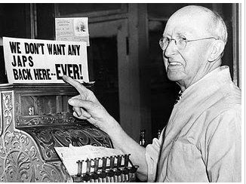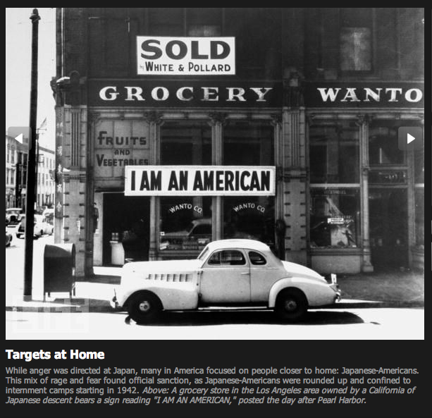
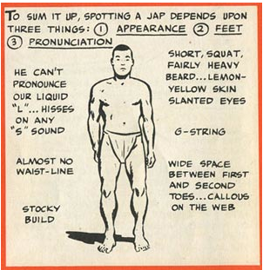
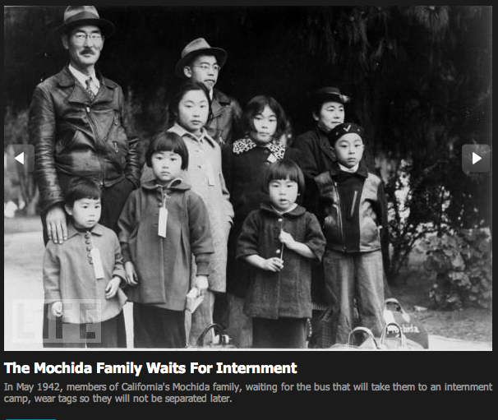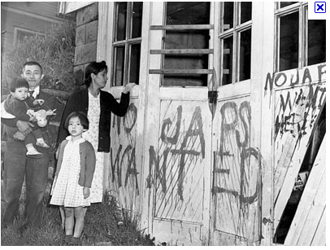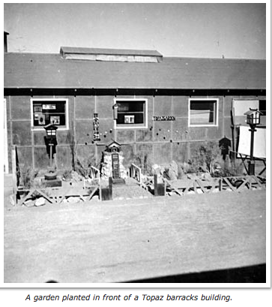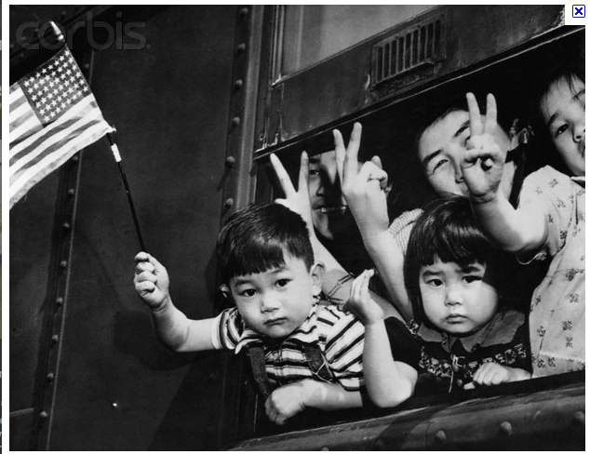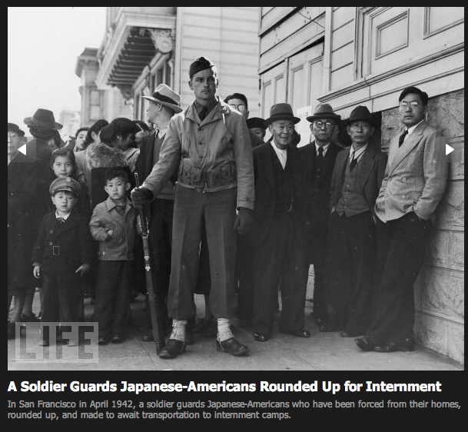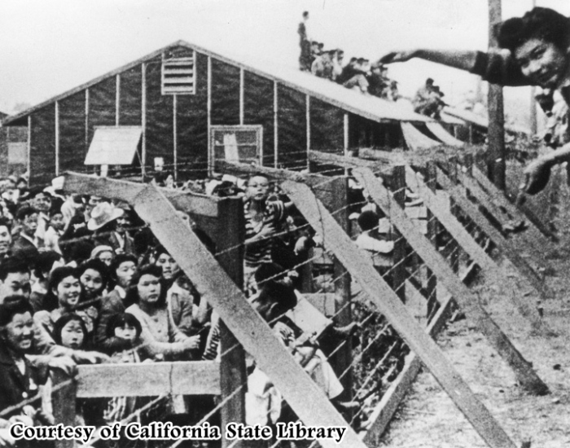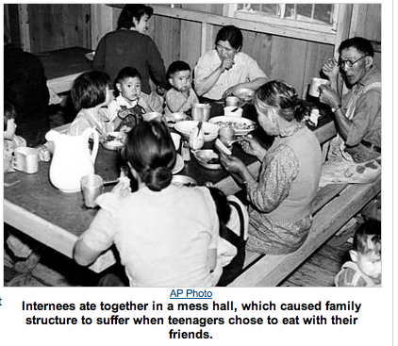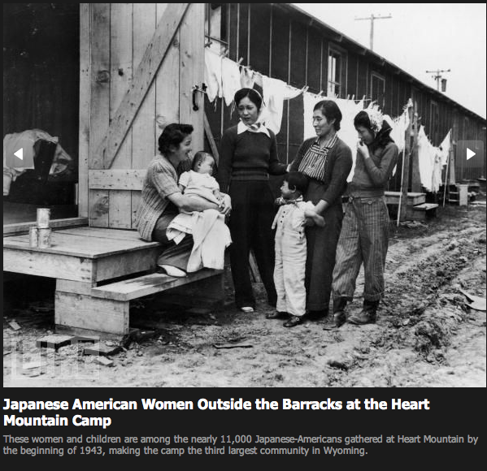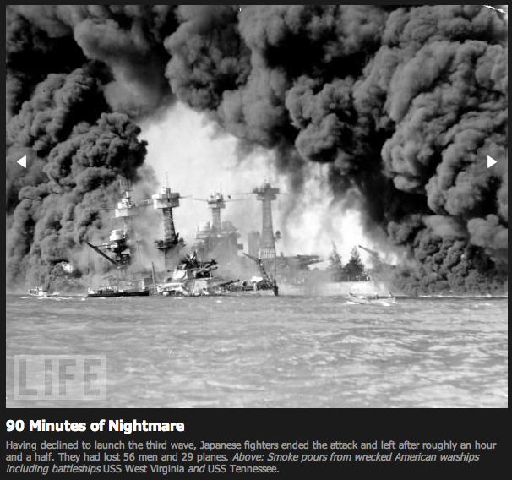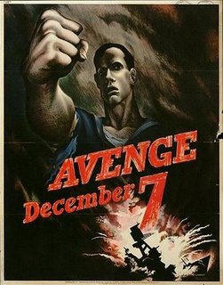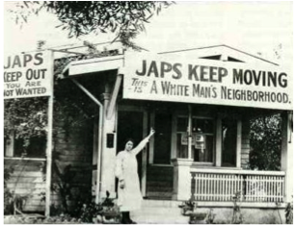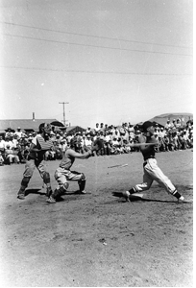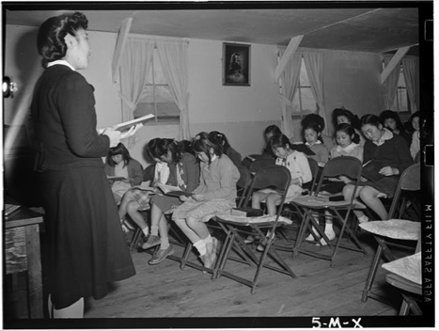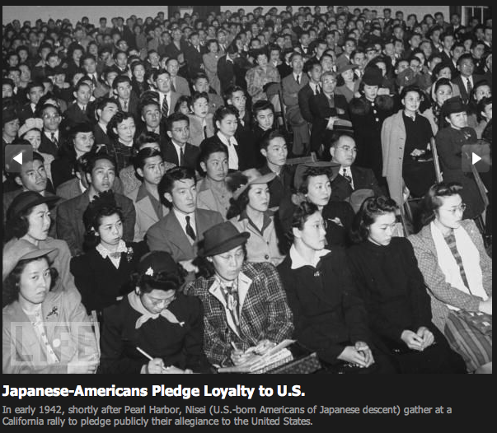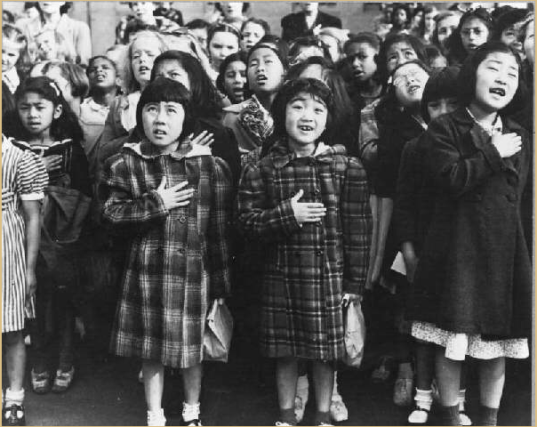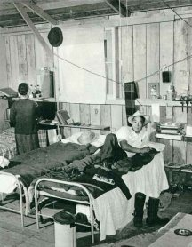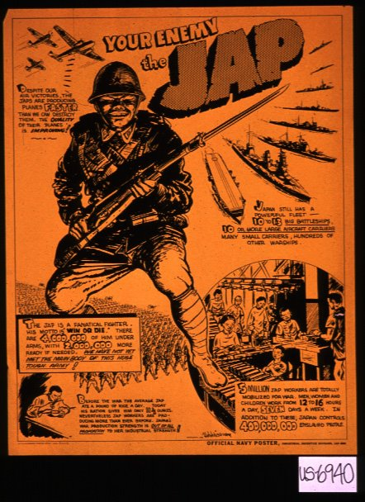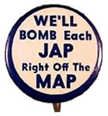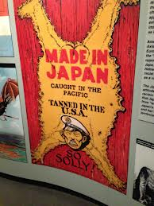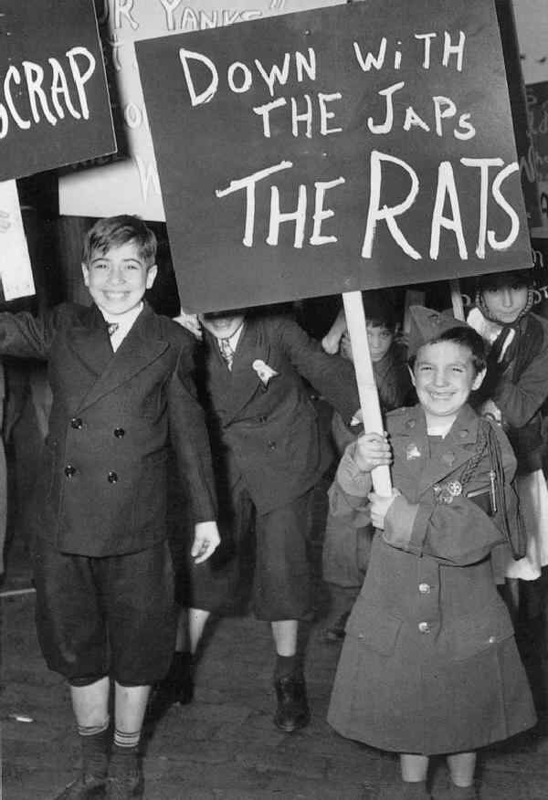
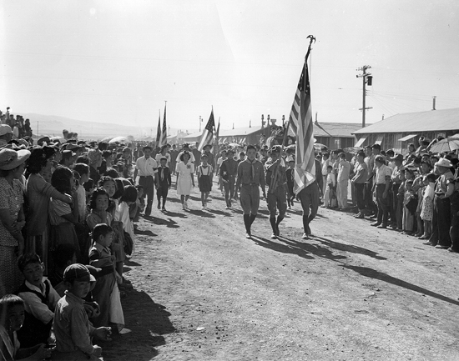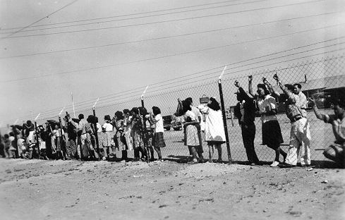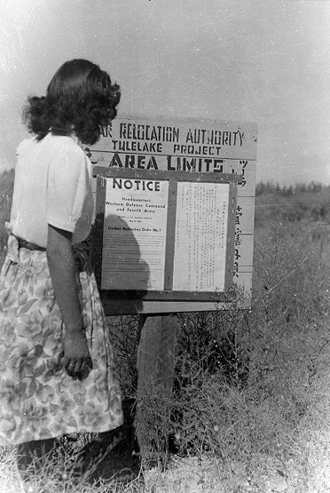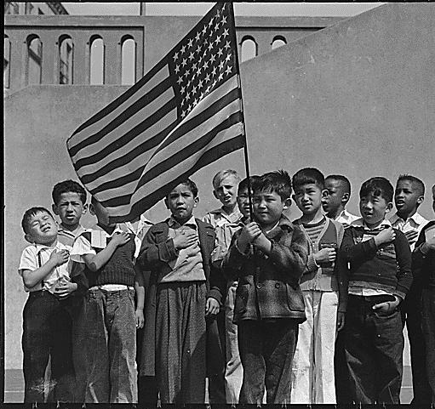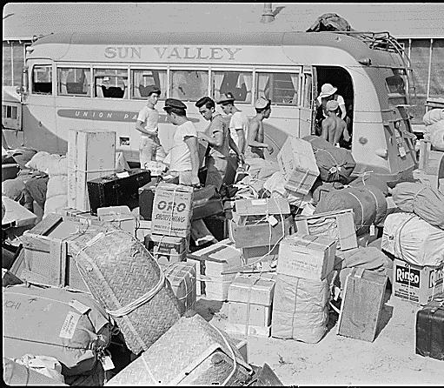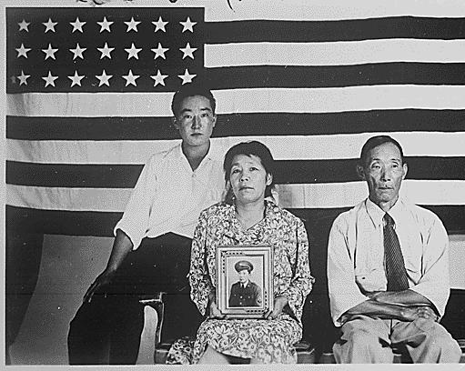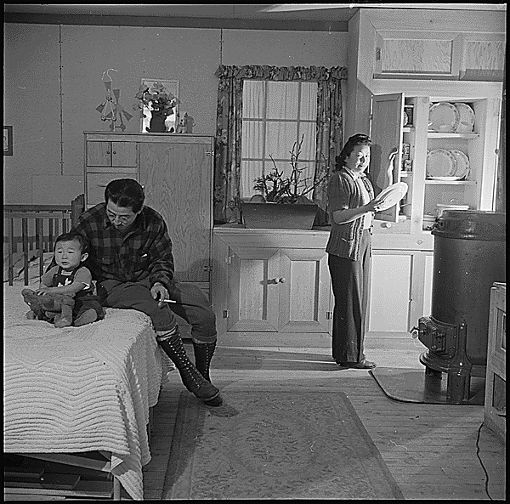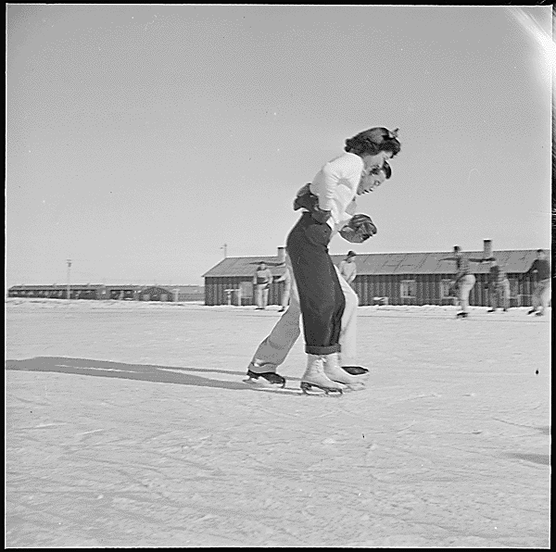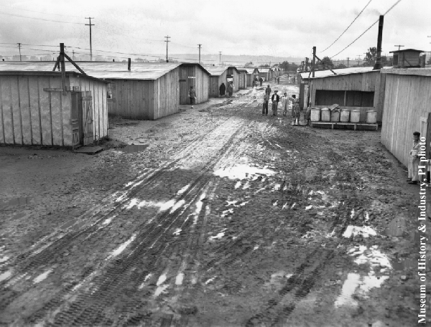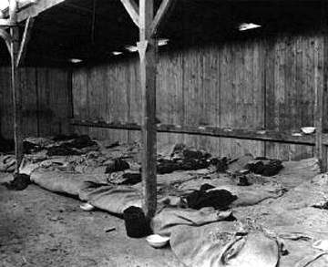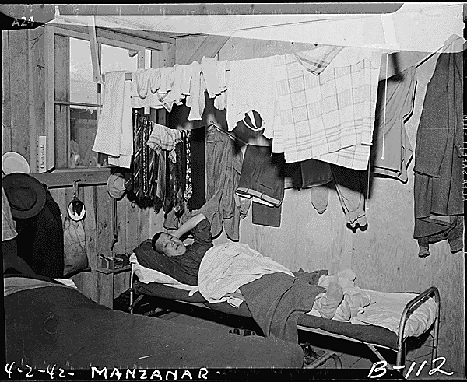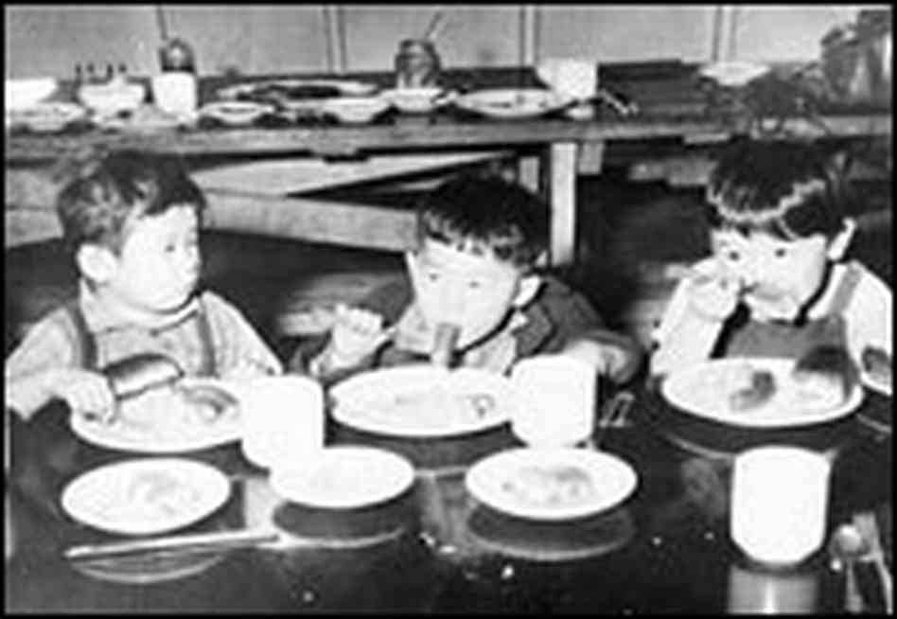

We saw all these people behind the fence, looking out, hanging onto the wire, and looking out because they were anxious to know who was coming in. But I will never forget the shocking feeling that human beings were behind this fence like animals [crying]. And we were going to also lose our freedom and walk inside of that gate and find ourselves…cooped up there…when the gates were shut, we knew that we had lost something that was very precious; that we were no longer free."
Mary Tsukamoto

