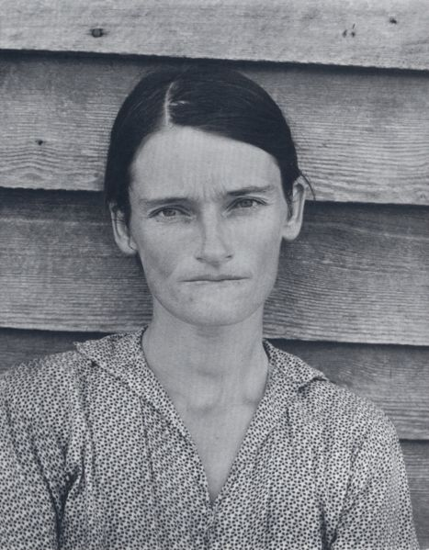
Allie Mae Burroughs, wife of cotton sharecropper. Hale County, Alabama.
Photo by Walker Evans (1935 or 1936) Farm Security Administration - Office of War Information Photograph Collection

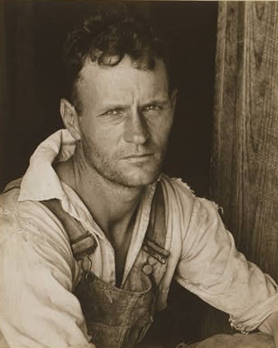

Pictures of the house and family of an Alabama cotton sharecropper / photographs by Walker Evans.
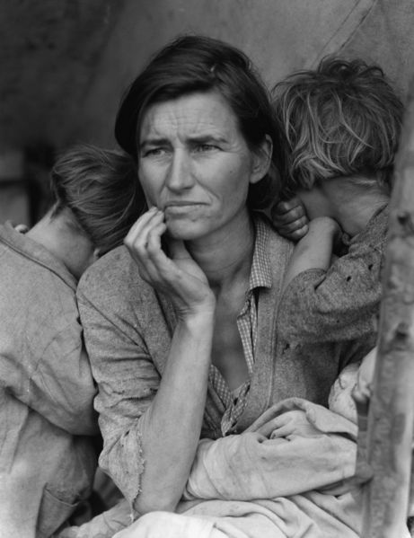
Dorothea Lange's Migrant Mother depicts destitute pea pickers in California, centering on Florence Owens Thompson, a mother of seven children, age 32, in Nipomo, California, March 1936.

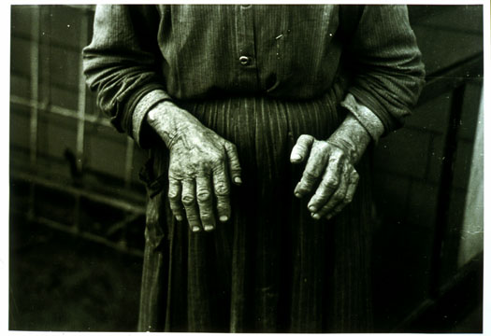
"Hands of Mrs. Andrew Ostermeyer, wife of a homesteader, Miller Township, Woodbury County, Iowa"
Photographer: Russell Lee
Date December 1936

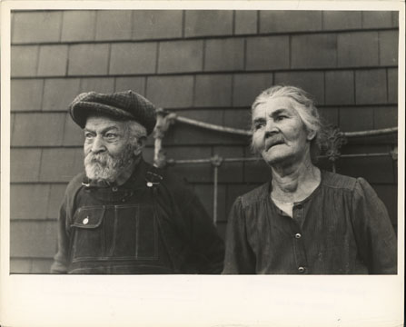
"Close up of Mr. and Mrs. Andrew Ostermeyer, homesteaders, Miller Township, Woodbury County, Iowa. They have lost their farm to a loan company"
Photographer: Russell Lee
Date December 1936

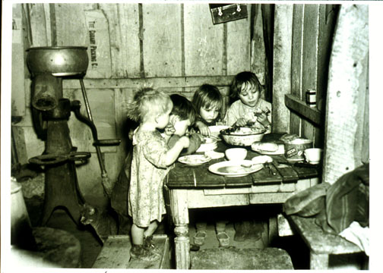
"Christmas dinner in home of Earl Pauley. Near Smithfield, Iowa. Dinner consisted of potatoes, cabbage and pie"
Photographer: Russell Lee
Date December 1936

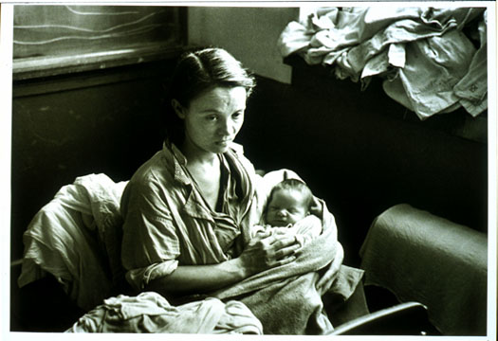
"Woman and child, flood refugees in schoolhouse, Sikeston, Missouri"
Photographer: Russell Lee
Date January 1937

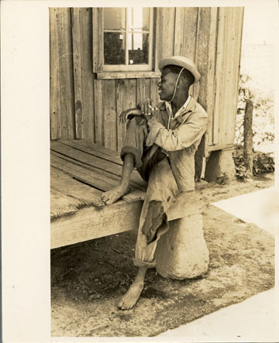
"Son of sharecropper sitting on front porch of shack home, New Madrid County, Missouri"
Photographer: Russell Lee 3
Date May 1938

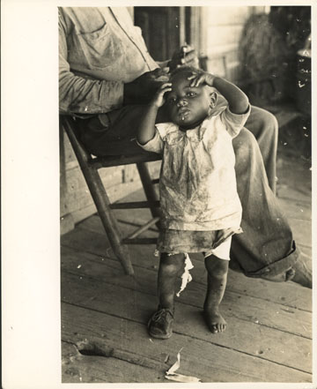
"Child of a sharecropper, Southeast Missouri Farms, New Madrid County, Missouri"
Photographer: Russell Lee
Date May 1938

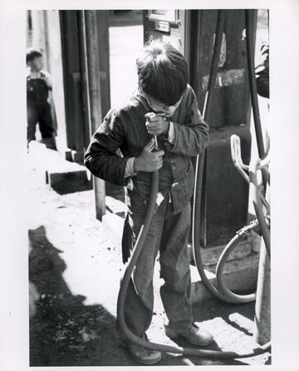
"Mexican migrant boy drinking out of a water hose at a filling station where the truck which is taking him home from Mississippi where he has been picking cotton has stopped. Neches, Texas"
Photographer: Russell Lee
Date October 1939

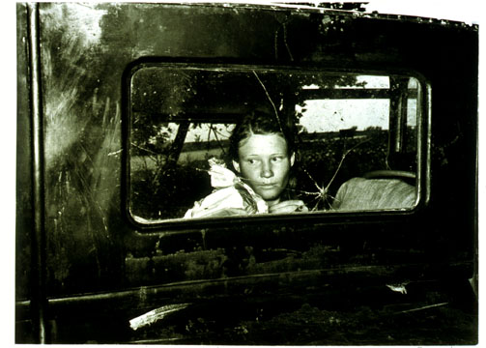
"Migrant worker looking through back window of automobile near Prague, Oklahoma. Lincoln County, Oklahoma"
Photographer: Russell Lee
Date June 1939

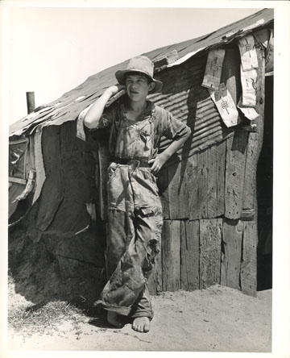
"Son of a day laborer living in Arkansas river bottom at Webber Falls, Oklahoma, Muskogee County, Oklahoma"
Photographer: Russell Lee
Date June 1939

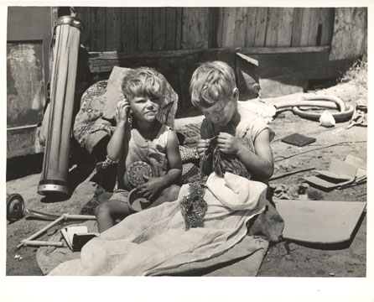
"Children of May's Avenue Camp, Oklahoma City, Oklahoma. Their father is a trasher and they are playing with some of the things he picked up."
Photographer: Russell Lee
Date July 1939

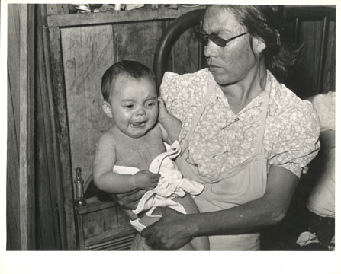
"Mexican mother and child with impetigo. Crystal City, Texas"
Photographer: Russell Lee Date March 1939

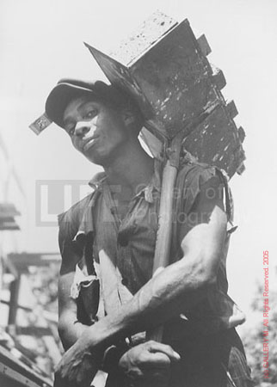
Brick Carrier at Model Community
1936
by Carl Mydans

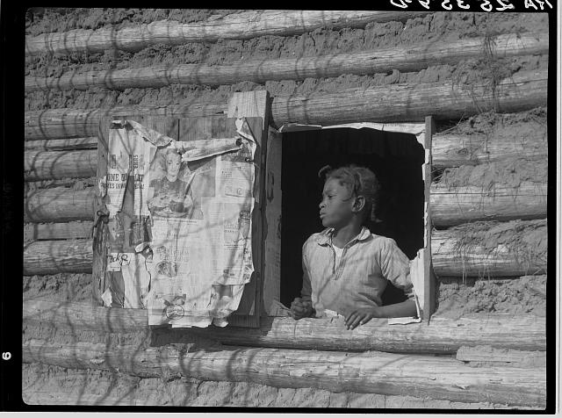
Artelia Bendolph.
Gee's Bend, Alabama, February and April 1937
Arthur Rothstein photographer

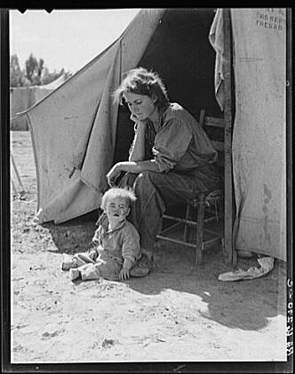
Dorothea Lange, photographer.
Imperial Valley, California, February and March 1937
Eighteen-year-old mother from Oklahoma, now a California migrant.

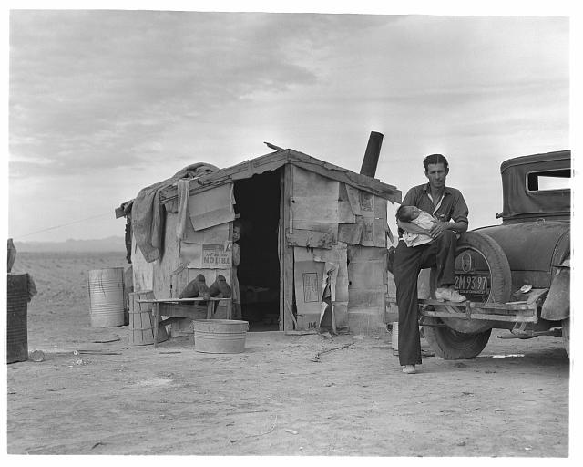
Dorothea Lange, photographer.
Imperial Valley, California, February and March 1937
Migratory Mexican field worker's home on the edge of a frozen pea field.

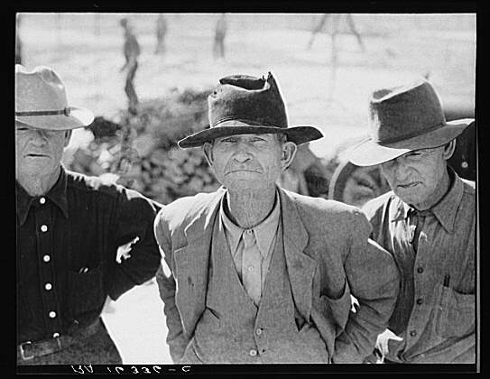

Dorothea Lange, photographer.
Imperial Valley, California, February and March 1937
Former tenant farmers on relief.

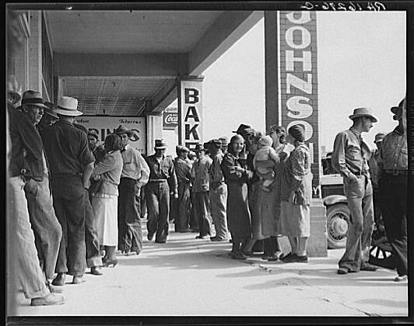

Dorothea Lange, photographer.
Imperial Valley, California, February and March 1937
Waiting for relief checks in Calipatria.

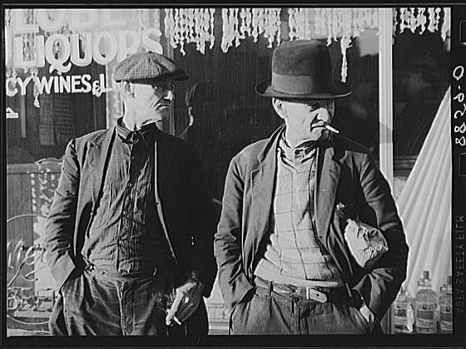
Photographer: John Vachon
Omaha, Nebraska, November 1938
Unemployed men who ride the freight trains from Omaha to Kansas City and St. Louis and back.

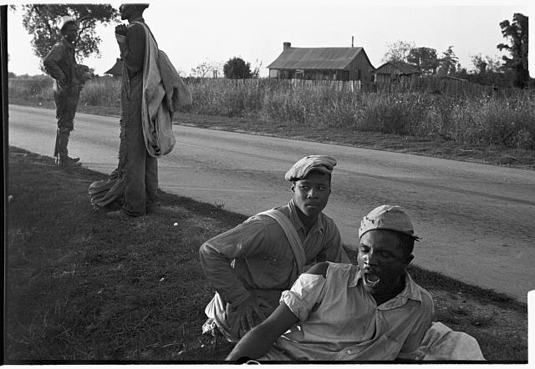
Pulaski County, Arkansas, October 1935
At the end of the day (of cotton picking).
Ben Shahn, photographer.

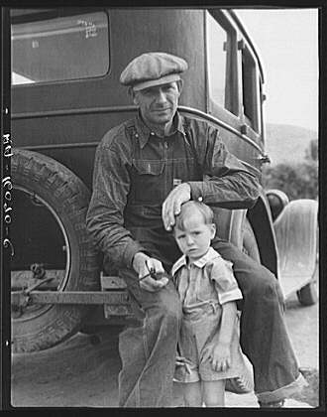
TITLE: 1936 drought refugee from Polk, Missouri. Awaiting the opening of orange picking season at Porterville, California 1936 Nov.
Dorothea Lange, photographer.

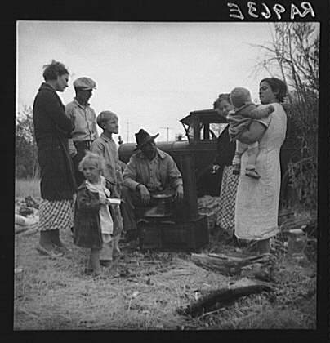

TITLE: Along the highway near Bakersfield, California. Dust bowl refugees
1935 Nov.
Dorothea Lange, photographer.

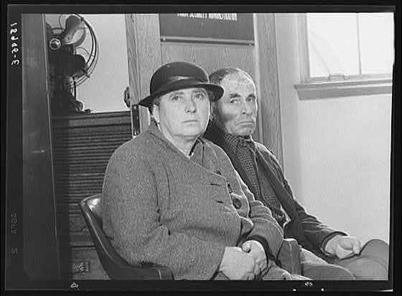

TITLE: Applicant couple, seeking aid under Tenant Purchase act. Stockton, California
1938 Dec.
Dorothea Lange, photographer.

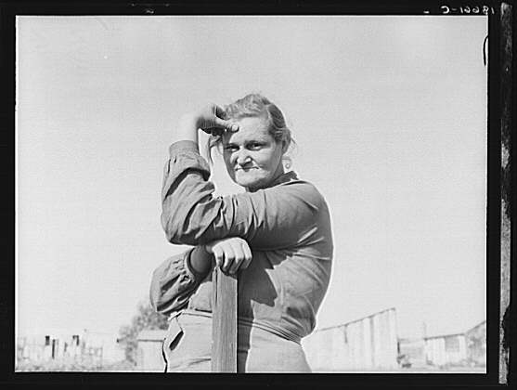

TITLE: Arkansas mother come to California for a new start, with husband and eleven children. Now a rural rehabilitation client. Tulare County, California
1938 Nov.
Dorothea Lange, photographer.

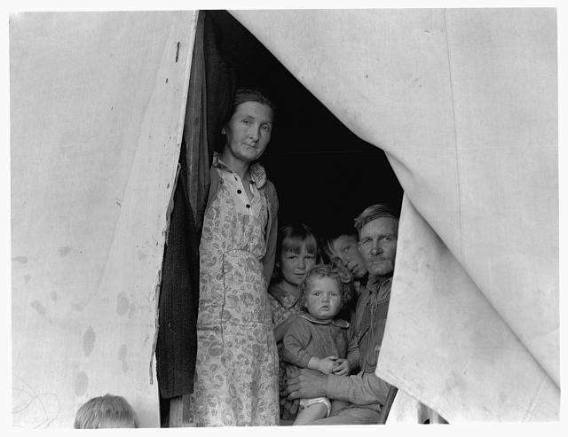

TITLE: Brawley, Imperial Valley. In Farm Security Administration (FSA) migratory labor camp. Family of mother, father and eleven children, originally from near Mangrum, Oklahoma, where he had been tenant farmer. Came to California in 1936 after the drought. Since then has been traveling from crop to crop in California, following the harvest. Six of the eleven children attend school wherever the family stops long enough. Five older children work along with the father and mother. February 23, two of the family have been lucky and "got a place" (a day's work) in the peas on the Sinclair ranch. Father had earned about one dollar and seventy-three cents for ten-hour day. Oldest daughter had earned one dollar and twenty-five cents. Form these earnings had to provide their transportation to the fields twenty miles away. Mother wants to return to Oklahoma, father unwilling. She says, "I want to go back to where we can live happy, live decent, and grow what we eat." He says, "We can't go the way I am now. We've got nothing in the world to farm with. I made my mistake when I came out here."
1939 Feb.
Dorothea Lange, photographer.

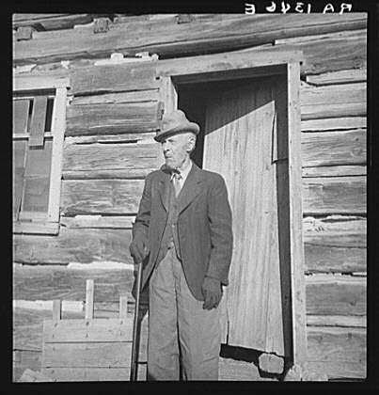

TITLE: Came to Utah from Denmark as a Mormon convert when a boy. Now ninety-five years old. Escalante, Utah
1936 Apr.
Dorothea Lange, photographer.

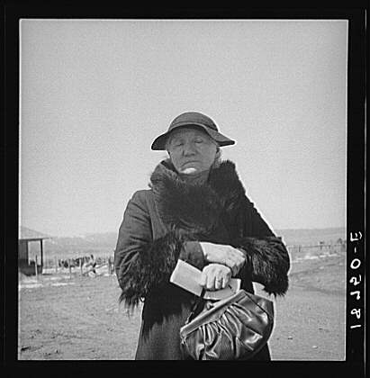

TITLE: Widtsoe, Utah. Morman woman, native of Denmark, receiving her first old age assistance check 1936 Mar.
Dorothea Lange, photographer.

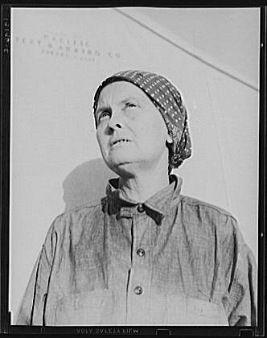
TITLE: Calipatria, Imperial Valley. In FSA (Farm Security Administration) emergency migratory labor camp. Left Oklahoma December 11, 1937 with husband and two children and son-in-law. Ex-tenant farmers on third and fourths in cotton. Had fifty dollars when set out. Went to Phoenix, picked cotton and pulled bolls, made eighty cents a day with two people picking bolls. Stayed until school closed. Went to Idaho, picked peas until August, left McCarl with forty dollars "in hand." Went to Cedar City and Parowan, Utah, a distance of 700 miles. Picked peas through September. Went to Hollister, Calipatria. Picked peas through October. Left for Calipatria for early peas which froze. Now receiving FSA food grant and waiting for work to begin. "Back in Oklahoma we was sinkin.' You work your head off for a crop and then see it burn up. You live in debts that you can never get out of. This isn't a good life, but I say it's a better life than that was."
1939 Feb. Dorothea Lange, photographer.

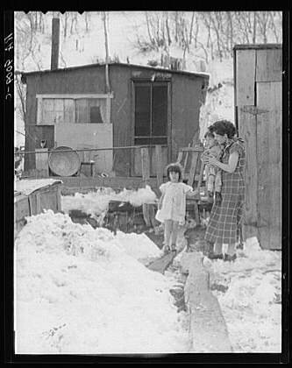

TITLE: Home and family of a Utah coal miner. Consumers, near Price, Utah
1936 Mar.
Dorothea Lange, photographer.

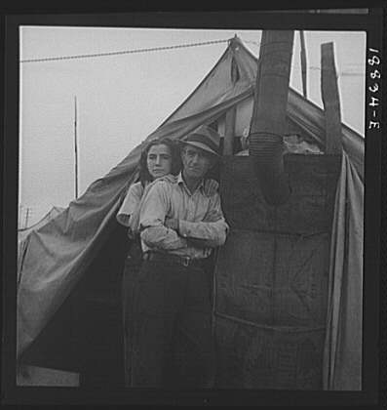

TITLE: Near Strathmore, California. From Wyoming and Missouri, eight years in California working in lemons "It's easy for us because we haven't got a bunch of kids to get drug around"
1939 Feb.
Dorothea Lange, photographer.

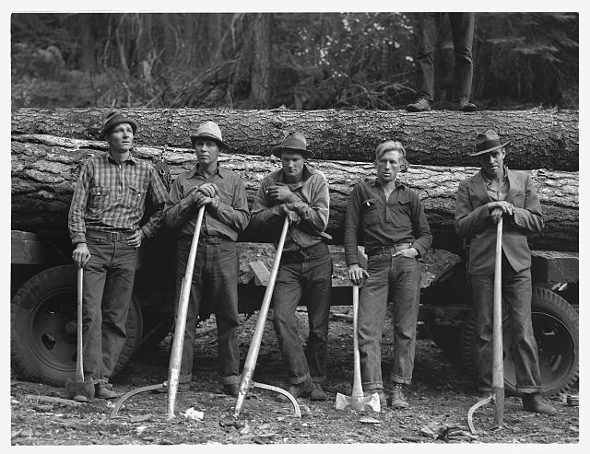

TITLE: Five members of Ola self-help sawmill co-op. Gem County, Idaho
1939 Oct.
Dorothea Lange, photographer.

