Name:
Period:

Women in the 1950s Graphic Organizer

 | Source:  Author/Date | What were suburban women doing?  (Evidence to support your answer) | How did they feel?  (Evidence to support your answer)
Document A
Document B
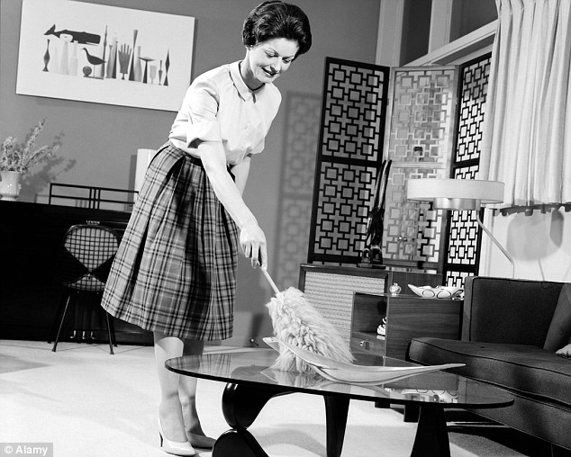
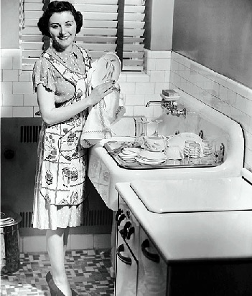
Hypothesis One: Is the image of a 1950s housewife accurate? Why or why not?

 | Source:  Author/Date | What were suburban women doing?  (Evidence to support your answer) | How did they feel?  (Evidence to support your answer)
Document C
Document D

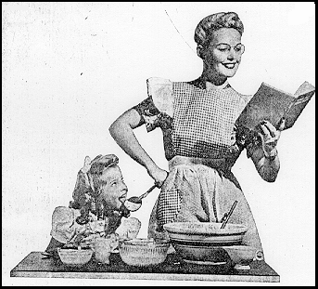
Final claim: Is the image of the happy 1950s housewife accurate? Why or why not? Use
2-4 pieces of evidence to support your claim.

